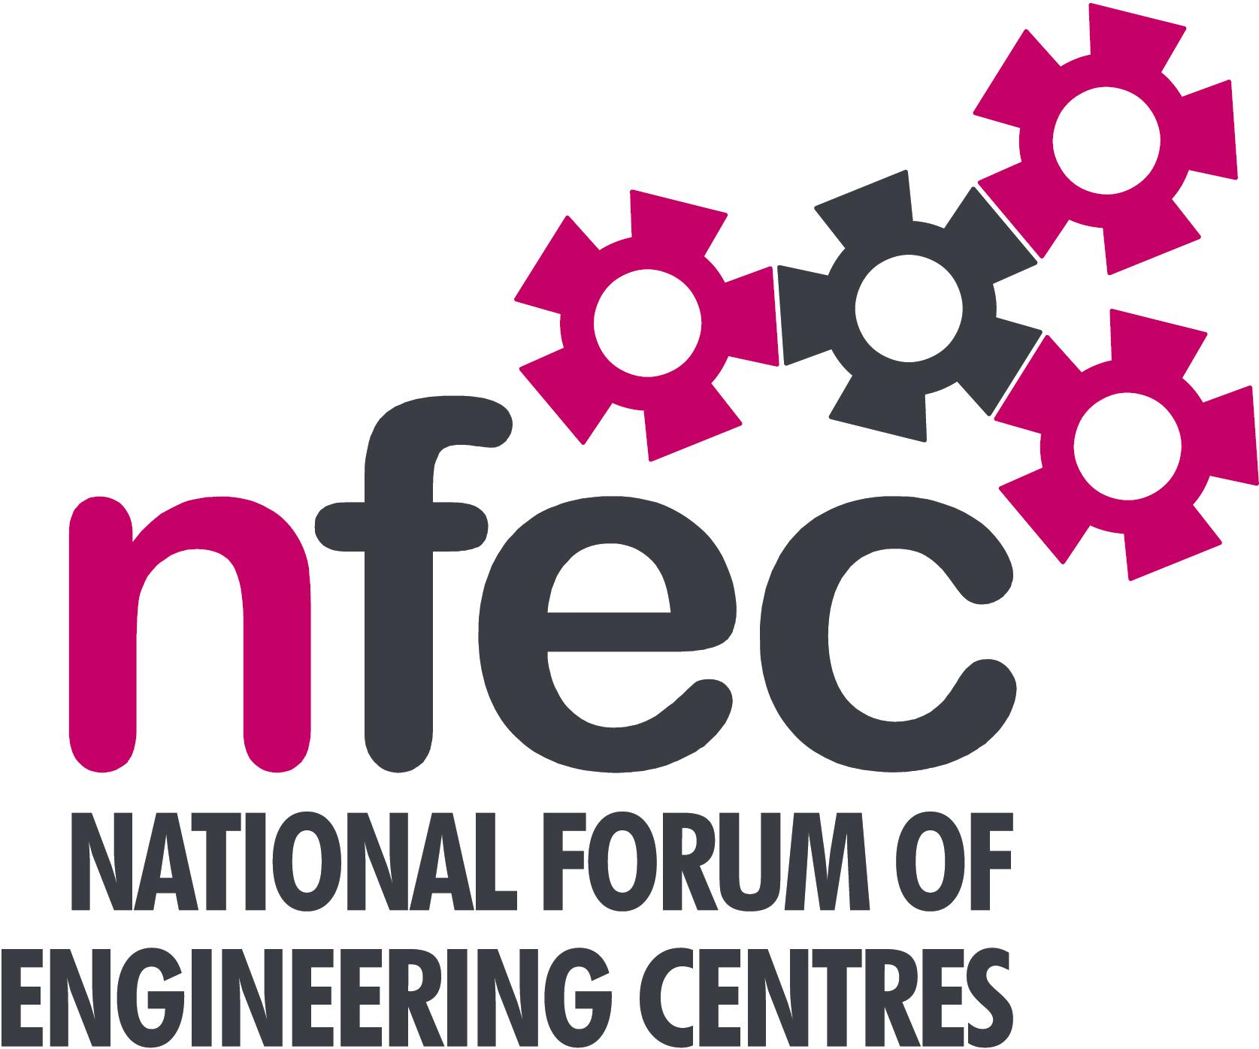
NFEC Autumn 2015 North West Regional Seminar

Host: Preston College

Friday 23rd October 2015, 10.15am – 15.00 (Coffee from 10.00am)
Venue: Preston College, Saint Vincent’s Road, Fulwood Campus, Preston, PR2 8UR
Telephone Number: 01772 225000

Programme

- Welcome and Introduction to the Seminar | Steve McAloone (Deputy NFEC North West Regional Coordinator)  Scott Cubitt, Preston College | 10.15
- Current matters of concern relating to quality, content, structure, management and delivery of programmes of training and education in Engineering (not included on Agenda) - an opportunity for open discussion with a focus to distill key issues and plans for addressing them.  - New Aprenticeship Trailblazer Initiative  - Update on recent Trailblazer developments  - Update on Delivery of the Mechatronics Programme with Automotive apprentices  - Qualifications and Awarding Bodies – Current developments and general issues.  - Tour of Facilities at Preston College  Lunch and Deomonstrations by Exhibitors  - Use of technology in learning and related Feltag issues  - Plenary session – Issues to note and agreed actions for NFEC | All Delegates/Steve McAloone  Bob Millington  Shane Parkes - NW Training Council  Mark Shepherd, Paul Kerwin - EAL  Amanda Murphy - Pearson  Simon Yorke - C&G  Richard Powell - AQA  All Delegates/Scott Cubitt  Kerry Culley - Furness College  All Delegates/Steve McAloone | 10.20  10.45  11.45  12.30  13.45  14.30
- Date, Place and Topics for next Seminar  Close  Entry is free to this seminar for members or non-members present for a first attendance.There will be a charge for non members after this. A light buffet lunch will be provided and you will be able to see/discuss demonstrations of the latest available equipment and facilities for the delivery of learning in Engineering. | All Delegates/Steve McAloone  To book your place: Email: admin@nfec.org.uk  Phone: 07759 901229 | 14.45

